Yeperenye Yaw promotional clothing

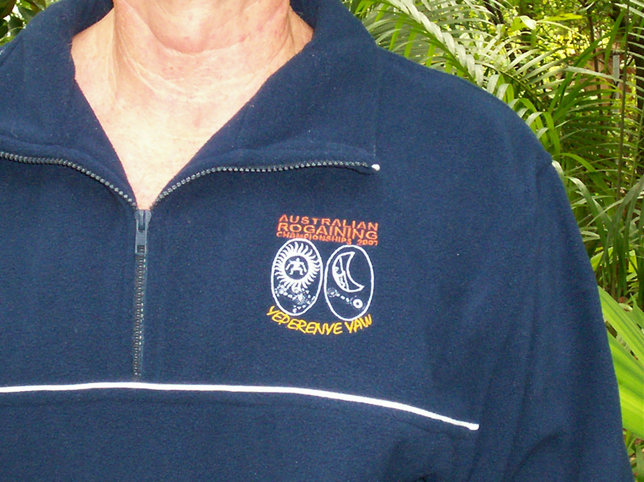

Polar Fleece long sleeve jumper….just perfect for the cold Our official event logo, which depicts a diagrammatic aboriginal
Alice Springs nights. $40 each representation of how the sun and the moon was made according to
local dreaming stories.



Pique knit polo shirt with fancy collar in Territory Ochre. $35 each The unisex sizing fits the ladies well and looks stunning on the
men too!
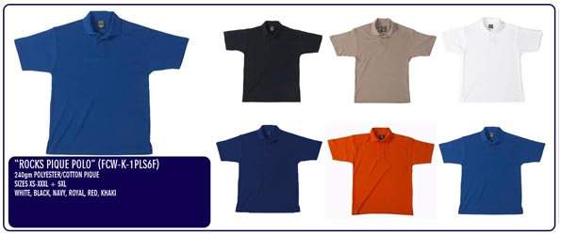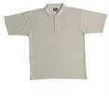
- Plain pique knit polo T-shirts available in the colours above.
- Logo will be situated on the top L) hand side as depicted in the photos.

