 |  | Northern Territory Rogaining Association  ‘Red Rocks & Green Grass  6 hour rogaine (2-8 pm) plus “come & try”  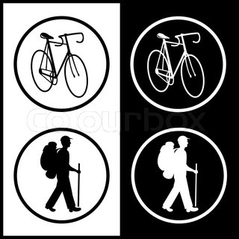  Saturday 21st June 2014 |  |  |  |  |  |  | Team No | Send completed form with SAE to:  RR&GG Rogaine  18 Kohinoor Street  Anula, NT, 0812  Or e-mail to:cmarrcmarr@bigpond.com
 | Gender category (X in box) |  |  | Men’s |  | Women’s |  | Mixed | Event type |  | Rogaine |  | Come & Try

Age category on day of event |  | Junior (13 to 17 yrs) |  | Open |  | Veteran’s (+ 40 yrs) |  | Super Veteran’s (over 55 yrs) |  | Family (min open & one junior)

Name, Postal Address and E-Mail for each team member (to receive results, newsletters etc.) |  |  | Phone number  & email (clearly please!) |  | Age | Sex  M/F | Event entry fees |  |  |  | $ Total
Please try to avoid changing your team's membership after lodging this form.  ALL team members MUST supply their complete address for insurance reasons. |  |  |  |  | Age | Sex  M/F | $E’bird | $ St'd | $ Late
Name 1 (team contact) | Address 1 (to receive your team's essential pre-event instructions)
Name 2 | Address 2
Name 3 | Address 3
Name 4 | Address 4
Name 5 | Address 5
 |  |  |  | Please write your whole team's total payment here ==>> $
“Annual Membership” fees no longer apply.
Event Fees (per person) | Adult | Junior (Under 18 yrs) | Under 13 yrs
Early bird (before Fri 18th June ) | $40 | $25 | $15
Standard | $45 | $30 | $20
Come and Try | TBA
Entries close Wed. 18th June. Late entries will be accepted at the organiser’s discretion. A late fee of $5 per person will apply.
 | Payment | Cheque | M/O | EFT | Cash
Administration | Received
Use only | Amount Due
 | Balance owing
 | Receipt number
Cheque or M/O | Bank
details | Branch
 | Payee
 | Cheque #
 | Indemnity Form | € Sent |  | € Received

- Teams must comprise of at least 2 members and no more than five.
- Under 13 year olds must be accompanied by an adult or junior competitor.
- Regulations, instructions and indemnity forms will be forwarded once a team has registered
- Cheques/money orders/EFT payable to “Northern Territory Rogaining Association Inc.”
- For EFT payments BSB: 065 901 Account No: 1055 9967 Account Name: “Northern Territory Rogaining Association Inc.” Please include name of 1 team member and “RR&GG ” in description field, ie Smith RR&GG
- Event fees cover course setting, vetting, maps, food, insurance, safety equipment and admin costs.
- If you e-mail us the entry form then you will receive all your event documentation electronically also.

