Next Rogaine:
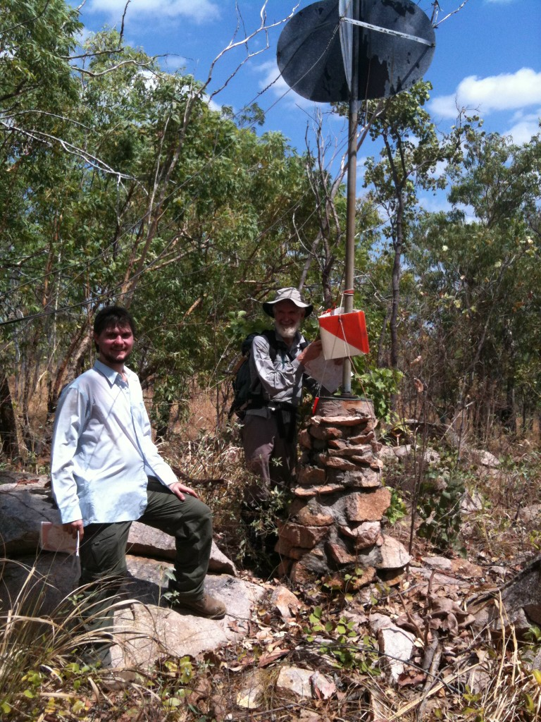

Saturday, 21st June 2014

6 Hour Rogaine, and in conjuction with, for the first time
"Come and Try" for the enthusiastic bush lovers who need help
navigating a topographic map.

Where: Coomalie Farm (just south of the Batchelor turn-off,
taking the next left turn.)

Start Time: 2 pm

Make a week-end of it. Camping is free.
Coomalie Farm was the site of much activity during WWII. It still
maintains a working airstrip and Chapel. Listen to local historian and owner of the property Richard Luxton give an interesting talk on Sunday morning about the history of Batchelor's strategic location and role during WWII. And did you know, that in 1945 at the Batchelor WWII Hospital site, was the place for the first human trials for Florey' and Chain's new antibiotic, "the wonder drug", on wounded or sick troops. Still today there are remnants of WWII scattered throughout the course, including much debris from everyday living. Some controls will include these special locations.
Contact the event secretary if you would like to take part but don’t have a partner.
Evening Meal and Breakfast will be provided and included as part of the Rogaine entry fee.
The “Come and try” option will have concessions on cost

Workshop/Coaching:
Prior to the event on 11th June, starting at 7 pm, the N.T. Rogaining Association will conduct a 2 hour workshop to assist those who would like to refine their rogaining strategies and map reading ability. This would be particularly beneficial to all newcomers.
- Learn the rules of rogaining;
- Reading a topographic map,
- How to plan your course;
- Refine your map reading ability, and
- Overall strategy to winning rogaines!
Bookings are essential, please telephone 8985 6885 or email seedymarj@gmail.com.au for more details.

